**Trello Board Submission**

**Please include the following information for your Trello board:**

A link to your publicTrello board should be provided here:

<https://trello.com/b/rZwPnmQd/web-develoment-project>

Include a screenshot of the board below:

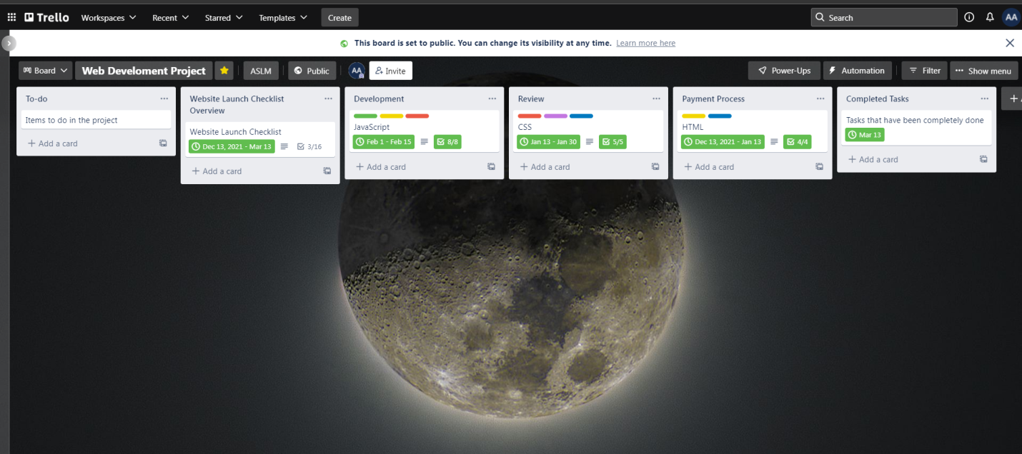S